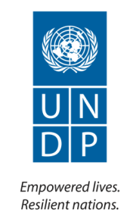

“Enhancing Capacities and Business Processes”: A Preparatory Support to Capacity Development for the Ministry of Foreign Affairs

Annual Report

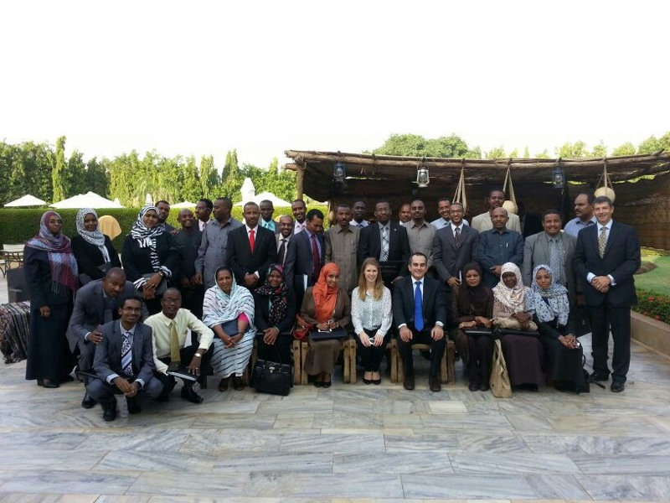

United Nations Development Programme

Implementing Agency: | United Nations Development Programme
Country/Region or Area: | Sudan / Khartoum
Project Title and ID: | “Enhancing Capacities and Business Processes”: A Preparatory Support to Capacity Development for the Ministry of Foreign Affairs (Atlas Project ID: 00086338)
Project Duration: | March 2013 to February 2014
Project Budget (AWP): | USD 140,000
Reporting Period: | January 2013 to December 2013
Total funds available (US $): | USD 140,000
Contact Person/s: | El Moiz Ismail, Programme Specialist, Elmoiz.ismail@undp.org  Intisar Salih, Managing Consultant, Intisar.salih@undp.org

Table of Contents

Acronyms

III. Progress Review: Key Activities and Results, <specify reporting period> 5

II. Introduction 4

IV. Monitoring and Evaluation 6

V. Key Challenges and Lessons Learned 6

VI. Major risks and mitigation measures 7

VII. Partnerships and Sustainability 7

VIII. Financial Summary 7

Annexes

(Note: Please use table of contents maker to ensure automatic updating of pages and content).
Use font Corbel and font size 10 for all text on narrative sections.

Acronyms

(Note: it should be arranged in alphabetical order)

UNDP  GoS  MFA  PIP  CDKN  UNITAR  RICARDO AEA  CC COP | United Nations Development Programme  Government of Sudan  Ministry of Foreign Affairs  Project Initiation Plan  Climate Change and Knowledge Network  United Nations Institute for Training and Research  Energy and Environment Consulting Agent  Climate Change Conference of Parties

- Executive Summary

The Project Initiation Plan (PIP) was signed in March 2013 between the Ministry of Foreign Affairs (MFA) and UNDP for one year project with an overall objective of providing Capacity Development support to MFA. The PIP was designed to achieve three output, first; improved organization and human capacities; second; upgraded business processes in the directorates of Peace and Humanitarian Affairs and Borders and Aliens and third; developed full fledge three year project document.

During the reporting period, substantive progress was achieved especially in the first two outputs. Under output one, three training activities to support the human capacities in the Ministry, including two training workshops on Multilateral Conferences and Climate Change Negotiation where conducted. The two workshops were designed and delivered with the support of the United Nations Institute for Training and Research (UNITAR) and additional funding from the Climate Change and Knowledge Network (CDKN). The third training was an English training on communicating across culture designed and delivered by the British Council. The three trainings were tailored to support a patch of young diplomats being prepared by the Ministry to serve the Sudanese Embassies abroad. Overall these trainings were attended by 81 professionals, including 15 participants from outside MFA.

The second main achievement of the PIP during the reporting period was the assessment of business process in four directorates namely; the Peace and Humanitarian Affairs, Borders and Aliens, Consulates and the Protocol General Directorate which includes both the Immunities and Privileges directorates. While the PIP indicates the assessment of only two directorates, the actual assessment covered four, based on a request from the Ministry to expand the process. Finding and general recommendations of the assessment were reviewed and approved by the Ministry. Accordingly, a development Plan for upgrading the business process in the four targeted directorates is now being finalized. The prospective development plan together with a three year training programme (which will be developed in collaboration with UNITAR) will represent main inputs for the full fledge project which will be developed in early 2914 for review and approval by UNDP and MFA. The finalization of the new PRODOC will mark the completion of the activities of this PIP.

An important achievement of the PIP during the reporting period was the establishment of the Project Office creating strong linkages and visibility of UNDP within MFA. Currently, an office space consist of two offices, a meeting room, reception and one path room is operational and integrated in MFA’s day-to-day services such as cleaning, drinking water supply and security.

The main challenge faced the project during the reporting period was the delay in the implementation due to the continuous changes of the project focal point within MFA. Moreover, the assembly and recruitment of the assessment team (national and international) took longer than expected due to the lengthy UNDP procurement procedures as well as the multilayer approval process.

The project expenditure as capture by the IPSAS System amounts to USD 101,086.18 including commitments. This expenditure represents 72, 2% of the total project budget ($ 140,000). However, the actual disbursements of the project amounts to 94% of the total budget. This discrepancy is due to the fact that an amount of $ 30,000, already paid to UNITAR based on UN to UN Agency Contribution Agreement signed in October, was not captured in Atlas because the liquidation report was sent late by UNITAR to UNDP (in January 2014).

- Introduction

The PIP overall objective is to provide Capacity Development support to the Ministry of Foreign Affairs (MFA). The specific objectives are:
1. To support the development of organizational and individual capacities in the Ministry of Foreign Affairs,
2. To map, assess, re-engineer and upgrade the business processes in the Peace and Humanitarian Affairs and Borders and Foreigners Directorates
3. To develop a three year full fledge project document.

These objectives were designed to be achieved through the following project activities:
1. Support to the Diplomatic Training Institute,
2. Diplomatic Training,
3. English Language Training,
4. Mapping and Assessing of Business Processes and communication Networks in the Peace and Humanitarian Affairs Directorate,
5. Upgrading of Business Processes and communication Networks in the Peace and Humanitarian Affairs Directorate,
6. Mapping and Assessing of Business Processes and communication Networks in the Borders and Foreigners Directorate,
7. Upgrading of Business Processes and communication Networks in the Borders and Foreigners Directorate,
8. Development of Project Document.

One of the important products of this PIP is to produce a project document for the support of Capacity Development of the Ministry of Foreign Affairs beyond March 2014 based on the lessons learned from the implementation of this preparatory project. The prospective project document to be produced is estimated around 1.3 million USD for 3 years. The prospective project will be funded from UNDP resources as well as Government of Sudan (Ministry of Foreign Affairs) cost sharing (in Sudanese Pounds) and any potential traditional and none traditional donors resources.

The project was prepared to contribute to the CPAP Outcome 1 and was specifically designed under the Indicative Country Programme Output (2): Relevant public institutions are better able to measure and assess socio-economic vulnerabilities and review related policies and strategies in support of poverty reduction and achievement of MDGs. At the Macro level the Project will contribute to the UNDAF Outcome 1: People in Sudan, with special attention to youth, women and populations in need, have improved opportunities for decent work and sustainable livelihoods and are better protected from external shocks, thereby reducing poverty.

This PIP is directly implemented by UNDP while the Project Office is hosted and supported by the Ministry of Foreign Affairs. The actual implementation of the PIP started in July 2013 with a four month delay due to delays resulting from assigning and or changing the project focal point within the Ministry of Foreign affairs. The PIP will be extended to May 2014 to complete its 2014 planned activities.

- Progress Review: Key Activities and Results: July – December, 2013

Section 1: Overall progress against outputs and outcomes

The Project was designed to contribute to the UNDAF Outcome 1: People in Sudan, with special attention to youth, women and populations in need, have improved opportunities for decent work and sustainable livelihoods and are better protected from external shocks, thereby reducing poverty.

During the reporting period, substantive progress was achieved especially in the first two outputs. Under output one, three training activities to support the human capacities in the Ministry, including two training workshops on Multilateral Conferences and Climate Change Negotiation where conducted. The two workshops were designed and delivered with the support of the United Nations Institute for Training and Research (UNITAR) and additional funding from the Climate Change and Knowledge Network (CDKN). The third training was an English training on communicating across culture designed and delivered by the British Council. The three trainings were tailored to support a patch of young diplomats being prepared by the Ministry to serve the Sudanese Embassies abroad. Overall these trainings were attended by 81 professionals, including 15 participants from outside MFA.

Section 2: Progress against each output

Project Output 1: Organizational and Individual Capacities Developed
Output indicators | Targets | Progress against targets
- Support provided to the Diplomatic Training Institute | Baseline: $30,000  AWP target: 30,000 | Reporting period:  Cumulative total: Out of 30,000 (baseline) now 20,775.75 was spent partially on the maintenance and renovation of the project office located at MFA and partially on covering the local cost of two training workshops conducted in Khartoum.
- Number of staff members of MFA receiving Diplomatic Training | Baseline: 30,000  AWP target: 30,000 | Reporting period: 30,000  Cumulative total: 30,000 spent through Inter UN Agency Agreement established between UNDP and UNITAR
- Number of staff members of MFA receiving Climate Change Negotiation Training | Baseline: 00  AWP target: 00 | Reporting period: 00  Cumulative total: Training fully funded by CDKN and Ricardo AEA through UNITAR
- Number of staff members of MFA receiving English Language Training | Baseline: 10,000  AWP target: 1o,000 | Reporting period: 8224.28  Cumulative total: Out of 10,000 (baseline) now 8224.28 spent through a sub contract with the British Council to cover designing and implementation of the training

Key Activities:

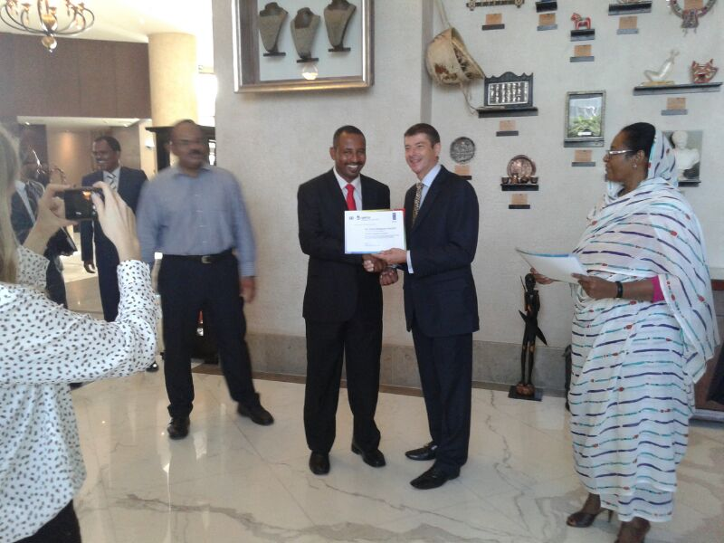
Include a picture relevant to the output as much as possible. This could also be graphs / diagrams that can further elaborate on achieved result

The following is a summary of activities under this output during the reporting period:

- Support to the Diplomatic Training Institute: The planned support did not take place. This activity was delayed by the Ministry until a clear decision is internally taken on the nature and level of support to be provided by the project. Until such decision is taken, it was agreed that the resources allocated for this purpose will be used for the renovation of the project office space as well as support the training activities.
- Training on Multilateral Conferences Negotiation: A two days workshop was conducted at AL Salam Rotana Hotel during the period 6-7 October. The workshop was designed and delivered by UNITAR, funded by UNDP and attended by 30 participants from MFA. The objective of the training was to strengthen the knowledge and skills of young diplomats in the field of multilateral conferences and negotiations. The workshop was co-led and delivered by two senior international resource persons.
- Training on Climate Change Diplomacy: A three day training workshop was conducted at Al Salam Rotana, back-to-back with the Multilateral Conferences Negotiation, during the period 8-10 October. The objective of the training was to strengthen negotiation skill and knowledge of the participants on the Sudan's key priorities on the road to COP19. The workshop which designed and delivered by UNITAR and funded by UNDP together with kind support from CDKN and Ricardo AEA Partners. The Training Workshop was attended by 30 professional, 50% from MFA and the rest came from the Higher Council for Environment, Ministry of Environment and the Environmental Conservation society (5 each). Technically, the training was delivered and supported by 7 high level international experts and benefited from the excellent mix of the participants in terms of knowledge sharing and exchange of experiences.
- English training on Communicating across Cultures: This was a sixty-hour training on Communicating across Culture designed and delivered by the British Council in Sudan, implemented over six weeks daily sessions. The training was focused on English for international communication with the objective of improving the participants fluency for key international and business communication conducted in English. The training was benefited 21 young diplomats from MFA.
- Key Results:
Output 1. Organizational and individual capacities of 4 Directorates within the Ministry of Foreign Affairs developed: Key results under this output during the reporting period are focused on improving the individual capacities as follows:
- Improved knowledge, skills and networking of 30 professionals on Multilateral Conferences was evident by the result of the evaluation conducted at the end of the workshop. All participants stated they would recommend the workshop to their colleagues. Some participants commented that the course had been “a great opportunity to discover the best method to represent our country effectively.” The majority of the participants left highly positive comments on both content and trainers, and many expressed a wish to do more training with UNITAR/UNDP. (reference: Workshop evaluation report)
- Improved knowledge, skills and networking of young diplomats on climate change negotiation. This was evident through the overall evaluation of the participants for the workshop which indicates that the workshop was very relevant and useful and the course objectives were met to the extent of high (64%) which is slightly below the target of 70%. The reason being some of the topics introduced and discussed during the training were very new especially among the young diplomat group. However, they indicated that this training has encouraged them to read and acquire more knowledge on this hot issue. (Reference: Workshop evaluation report).
- Improvement of the knowledge and capacities of participants on general English and communication across culture in particular is clearly reflected in the individual participants evaluation undertaken by the British Council after the completion of the training ( Reference: evaluation reports)
- One of the key results under this output is the partnership with UNITAR. As a result of the collaboration mentioned above, UNITAR will play an important role in designing and developing a three year training plan for MFA. This role includes designing strategy for long term human capacity of MFA as well as assisting UNDP and MFA in the resource mobilization for the implementation of the training proposal. A draft list of training courses was already prepared and now being reviewed by the Training Directorate in MFA

Project Output 2: O Business processes of Peace and Humanitarian Affairs and Borders and Boarders and Aliens Directorates upgraded :
Output indicators | Targets | Progress against targets
- Mapping of business processes in the Directorates of Peace and Humanitarian Affairs and Borders and Aliens completed | Baseline: 7,500  AWP target: 7,500 | Reporting period: 7500  Cumulative total: Out of 7,500(b baseline) now 7,500 was spent on national and international consultants.
- Development plan to upgrade business processes and communication networks is formulated | Baseline: 7,500  AWP target: 7500 | Reporting period:  Cumulative total: out of the $ 7500 (baseline) now 6,649.71 was spent on national and international consultants. A commitment of $ 19,500 remains to be paid to the international consultant.

Key Activities:

Include a picture relevant to the output as much as possible. This could also be graphs / diagrams that can further elaborate on achieved result

Two main activities implemented under this output:

- Assessment of business processes in two directorates namely Peace and Humanitarian Affairs and Borders and Aliens Directorate: At the onset of the assessment, the Ministry requested the expansion of the assessment scope to cover two additional directorates. These are the Consulates Directorates and the Protocol General Directorate; the later includes the Immunities and Privileges directorates. The assessment was conducted by a Team of three consultants; two national and an international as a team leader. The assessment involved extensive discussions and meetings with diplomatic and administrative staff within each directorate as well as review of all related files and documentations. The assessment of the four directorates was completed as planned. The draft report and the main findings and recommendation were discussed and approved by the Project Board. The final report is due before Mid-January. This activity was planned to conclude by Mid-November, however, the addition of two more directorates has led to delay in the production of the final version of the report by almost two months.

- Designing and preparation of the development and upgrading plan: The broad recommendations on the development design were discussed and approved by the MFA. The detailed development plan including possible scenarios and option to upgrade and automate the business processes is being developed by the team of the consultant. The draft report will be ready before the end of January 2014.

- Key Results:
The project managed to make a good progress towards achieving the project indicators under this output:
- The assessment report of the current state of the business processes was completed for four directorates exceeding the level of the agreed indicator which is the assessment of only two directorates. The final draft report will be shared with MFA by Mid-January 2014.
The main findings and recommendations of the Assessment which were discussed and approved by MFA included the following:
- Introduction of secured Web Portal providing online dynamic services for MFA partners (Local and International). The portal should feature:
  - Information and Guidelines
  - Online application forms with status tracking capability
    - Diplomatic Bodies requests (Visa’s, Permits, …) (Phase I)
    - Consular Services for:
      - Sudanese abroad
      - Foreigners
  - Circulars and Announcements
  - News and events
While the portal is recommended for MFA to start immediately, other partners such as Airport, Passport & Immigration and Security bodies could join in the second phase after the launch of the portal.

- A Content Management System (CMS), including:
  - Workflow/Business Process Management Engine.
  - An Archiving System (for Scanned Documents, Electronic Documents, Audio and Video),
  - Integrated Databases covering all services provided (ID cards, Visa’s, Vehicles, …)
- Standardized document templates (.dot to be linked with the Workflow system)
- Business-Process-Mining to be applied to the accumulated content after 6-12 months of operation

At the Organizational level the Assessment recommended:
- An in depth study of the organization structure to properly merge similar directorates and regroup directorates of the same line under the same general directorate.
- Visits to similar MFA’s in other countries may be in order (e.g. Malaysia)
- A Human Resource study to define a clear HR for enhancing the professional capacity within MFA, including training the various functions within ministry in order to minimize the effect of high staff rotation rate.

- The second result under this output is the finalization of the development plan: The plan is partially completed for four directorates instead of two. Broad recommendations and options were indicated above already discussed and approved by MFA. The detailed development plan is being finalized will be ready before the end of January. The indicator is expected to be fulfilled before the end of January instead of December due to increase in the number of directorates to be covered by the assessment and the development plan.

Project Output 3: Project Document Developed and Direct Project Management Support Provided
Output indicators | Targets | Progress against targets
- Project Team on board | Baseline: 55,000  AWP target: ,000 | Reporting period: 55,000  Cumulative total: Out of 55 ,000 (baseline) now 17,936.47 was spent on project management and office operation during the reporting
- A three years project document for the support to Capacity Development for MFA developed | Indicator  Development of a 3 years project document for the support to Capacity Development for MoFA  Baseline  A 3 years project document for the support to Capacity Development for MoFA has not been developed | The project has started formulating the three years project document

Key Activities:

Include a picture relevant to the output as much as possible. This could also be graphs / diagrams that can further elaborate on achieved result

Key activities implemented under this output include:

- Recruitment of the Project Manager: A national Managing consultant joined the project and resumed management duties at the end of July, 2013.
- Renovation of the Project Office: The office space allocated by MFA (old conference hall) for the use of the UNDP Project was renovated, partitioned, wired for internet and telephone connectivity, furnished and fully streamlined into MFA service provision system. Currently an office space consisting of two offices, one meeting room, reception and a bathroom is operational and available for the use of the project during the coming few year.

- Key Results:
The project managed to make a good progress towards achieving the project indicators mentioned above.
- The project is operational with needed capacities in place. The existence of the project office within MFA premises very much improved the visibility of UNDP inside the Ministry and set the foundation for future collaboration.
- With regards to the second indicator on the development and formulation of a three year project; the achievement of this result is actually behind schedule due to the delays associated with the finalization of the development plan which provides a crucial input to the new project. On the other hand the delay in achieving the result is also linked to the delay in the UNITAR mission planned originally for November. The fulfilment of the indicator is scheduled for March/April 2014.

- Monitoring and Evaluation

Monitoring of activities was undertaken by the UNDP Managing Consultant and the UNDP Capacity Development Specialist as part of the day today management and coordination processes. The project activities are also monitored through continuous follow-up of the Head of the Peace and Humanitarian Directorate in MFA which the Govt Focal Point for the Project as well as through meetings of the Project Board .The nature of the PIP activities did not entails the establishment of a complicated system, however, the upcoming three years project will have a more comprehensive monitoring system to ensure effective implementation and track impact.

- Key Challenges, Lessons Learned and Recommendations

Key Challenges:
- Continuous change in the project focal point within MFA delayed the actual start of the PIP activities by almost four months.
- Procurement of national and international consultants was very lengthy and involved lots of efforts and time beyond what was expected. The operational process included too many steps and check points that led to lots of delays.

Lessons Learned:
- Involvement of the UNITAR in the project was advantageous in terms of resource mobilization, knowledge sharing, and exchange of experience and ideas from similar institutions. UNITAR was also able to mobilize top niche international consultants
- The involvement of the British Council in designing and delivering professional English training proved to be very successful. Further involvement in the full fledge project should be considered.
- Update on risks and mitigation measures

During the reporting period the two main risks included in the project risk log’ namely; the implementation of the project requires coordination between various Directorates in MFA; and the Sustainability of impact of this preparatory project continues to exist. While the first risk is currently being reduced through the establishment of the project office within MFA to facilitate and improve the coordination between directorates vis-vis the project activities, the risk of the continuity and sustainability of impact of the PIP remain at high level and will only be reduced when the full fledge project is developed, approved, funded by both UNDP and the Government and implementation progressed.

- Partnerships and Sustainability

During the implementation period the project manage to establish the following partnership:
- Partnership with UNITAR: while UNITAR was identified by the PIP as a partner to design and implement the diplomatic training programme, the actual achievement went beyond and resulted in mobilizing additional resources and other partners such as Climate Change Knowledge and Net Work (CDKN) and Ricardo AEA who were not part of the PIP. This partnership resulted in the implementation of a two training workshop on conference diplomacy and Climate Change Negotiations, attended by 30 professionals (each workshop) from MFA, Ministry of Environment, HCENR and FNC. The workshops which were conducted in Khartoum Alarm Rotan were delivered by high level international 7 experts mobilized by UNITAR. Furthermore this partnership resulted in the agreement that UNITAR will play a key role in the formulation and resources mobilization of the human capacity building component of the full fledge project.
- Partnership with British Council: UNDP partnered with the British Council to provide high level English training to the young and newly recruited diplomats in MFA. The partnership resulted in the training of 21 for six weeks. The focus of the Training was communicating across culture. As a result MFA requested more training to be provided to other categories including the administrative staff.

- Financial Summary

Table 1: Overview of available resources for the project duration

(Total funds received from different donors and also the budget for the year from AWP)

Table 2: Overview of allocation and expenditure per output
Output | Planned Budget (USD) |  | Expenses (USD) |  | Balance
Output | UNDP (TRAC) | Total | (TRAC) | Total | Balance
Development of Organization and Individual Capacities | 70,000.00 | 70,000.00 | 69,000.00 | 69,000.00 | 1,000.00
Upgrade Business Processes | 15,000.00 | 15,000.00 | 14,149.71 | 14,149.71 | 850.29
Direct Project Management Support | 55,000.00 | 55,000.00 | 17,936.47 | 17,936.47 | 37,063.53
TOTAL | 140,000.00 | 140,000.00 | 101,086.18 | 101,086.18 | 38,913.82

Note:

The project still has commitment of 22,163 to be paid to the international consultant and renovation contractor.

Table 3: Overview of expenditures

Data contained in this report is an extract from UNDP financial records. All financial information provided above is provisional. Certified financial statements will be provided in <March 2014>.

Annex 1: Progress Review: detailed matrix of activities and results

CPAP outcome: Relevant public institutions are better able to measure and assess socio-economic vulnerabilities and review related policies and strategies in support of poverty reduction and achievement of MDGs

Output 1 | Indicators |  | Baseline | Annual target | Progress / target
Organizational and individual capacities of 4 Directorates within the Ministry of Foreign Affairs developed:  Budget: 70,000,000  Expenditure to date: 69,000 | - Support provided to the Diplomatic Training Institute  - 2. Number of staff members of MFA receiving Diplomatic Training supported by the project  - 3. Number of staff members of MFA receiving English Language Training supported by the project |  | 70,000 | 70,000 | 69,000
 | - 81 professional trained  - Project office renovated and furnished |  | 100% | 100% | 98.5%
Planned activities |  | Results
Support to the Diplomatic Training Institute |  | Support delayed by MFA
Training on Climate Change Negotiation |  | 30 professional trained
Training on Multilateral Conference Diplomacy |  | 30 professional trained
English training for diplomats |  | 21 diplomats trained on Communicating across culture
Output 2 | Indicators |  | Baseline | Annual target | Progress / target
Business processes of Peace and Humanitarian Affairs and Borders and Aliens Directorates upgraded  Budget: 15,000,000  Expenditure to date: 14,149.71 | Mapping of business processes in the Directorates of Peace and Humanitarian Affairs and Borders and Foreigners |  | 7,5000 | 7,500 | 100%
 | - Assessing business processes and communication networks in the Directorates of Peace and Humanitarian Affairs and Borders and Foreigners  - Formulating plans for Developing business processes and communication networks in the Directorates of Peace and Humanitarian Affairs and Borders and Foreigners |  | 7,500% | 7,500 | 88.7%
Planned activities |  | Results
Mapping and Assessing of Business Processes and Communication Networks in the the Peace and Humanitarian Affairs and Borders and Aliens Directorates |  | Assessment of 4 directorates instead of two completed and report shared with MFA
Upgrading of Business Processes in the Peace and Humanitarian Affairs Directorate Affairs and Borders and Foreigners Directorates |  | Design and preparation of upgrading and development plan for four directorates instead of two is being finalized
Output 3 | Indicators |  | Baseline | Annual target | Progress / target
Project Document Developed  and Direct Project Management  Support Provided  Budget: 55,000,000  Expenditure to date: 17,936.47 | Recruitment of project team and management support |  | 40,000 | 17,936.47 | 44,8%
 | Development of a 3 years project document for the support to Capacity Development for MFA |  | 15,000 | 00 | 00
Planned activities |  | Results
Recruitment of project manager and operationalization of project office |  | Project Consulting Manager is on board since July 2013.  The Project office is fully functional.
Development of PRODOC |  | PRODOC will be developed in 2014 after the finalization of the development plan which was expanded to cover four directorates rather than two as identified in the PIP

Note: Repeat each table for every output so that it will be easier to manage and much more clearer in presenting.

Annex II: Updated Risk Log

(See project risk log and include it here to show any updates and mitigation measures)

Risks | Mitigation Measures
The implementation of the project requires coordination between various Directorates in the MFA | A Project inside the premises of MFA was established, equipped and supported by a managing consultant to facilitate the coordination process.
Sustainability of impact of this preparatory project | UNDP and MFA are planning to finalize a three year full fledge project to ensure the implementation of the development plan of the business process as well as a comprehensive training programme for both diplomats and administrative staff

For annual reports only:

Annex III: Annual Work Plan (for next year)

“Enhancing Capacities and Business Processes”: A Preparatory Support to Capacity Development for the Ministry of Foreign Affairs
EXPECTED OUTPUTS | PLANNED ACTIVITIES | TIMEFRAME |  |  |  | RESPONSIBLE PARTY | PLANNED BUDGET
EXPECTED OUTPUTS | PLANNED ACTIVITIES | Q1 | Q2 | Q3 | Q4 | RESPONSIBLE PARTY | Funding Source | Budget Description | Amount (in USD)
Output 2:  Business processes of four directorates upgraded  Baseline: Baseline in the year 2013:  No plans for Developing business processes and communication networks in the four Directorates  Indicators:  Number of formulated plans for Developing business processes and communication networks  Targets:  Four plans for Developing business processes and communication networks in four Directorates in the Ministry of Foreign Affairs  Related UNDP Country Programme Output:  Relevant public institutions are better able to measure and assess socio-economic  vulnerabilities and review related policies and strategies in support of poverty reduction and achievement of MDGs | Upgrading of Business Processes in four directorates | √ | √ |  |  | UNDP | UNDP | International Consultant | 30000
Output 3:  Project Document Developed  and Project Management  Provided  Baseline in 2013:  1. Project team (two staff members) has not been recruited  2. No project document developed (A 3 years project document for the support to Capacity Development for MoFA)  Indicators:  1. Number of recruited project team members  2. Developed 3 years project document for the support to Capacity Development for MoFA  Targets:  1. Two staff recruited as project management team  2. Development of a 3 years project document for the support to Capacity Development for MoFA  Related CP outcome:  Relevant public institutions are better able to measure and assess socio-economic vulnerabilities and review related policies and strategies in support of poverty reduction and achievement of MDGs | Management | √ | √ |  |  | UNDP | UNDP | Contractual Services - Individuals | 0
 | Management | √ | √ |  |  | UNDP | UNDP | National Consultant | 0
 | Management | √ | √ |  |  | UNDP | UNDP | ICT Equipment | 6,800
 | Management | √ | √ |  |  | UNDP | UNDP | Maintenance of Equipment | 1,000
 | Management | √ | √ |  |  | UNDP | UNDP | Supplies | 1,000
 | Management | √ | √ |  |  | UNDP | UNDP | Travel | 0
 | Management | √ | √ |  |  | UNDP | UNDP | Security and Communication | 1200
TOTAL |  |  |  |  |  |  |  |  | 40,000

Annex IV: Assets inventory (only for annual reports. Template attached as applicable).

